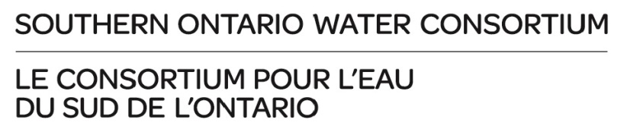
Advancing Water Technologies (AWT) Program
Subsidies for Biosolids Projects – Expression of Interest

Information obtained from this document will be used to determine applicant and project eligibility. The information provided in this form may be shared with SOWC advisors. It should NOT contain any confidential information. This form should be no more than 2 pages in length.

For information on the AWT Program, please review the Program Guidelines and Addendum for Large Projects (if applicable).

Company Contact Information (please fill in)

Name:
Title:
Company Name:
Full Address:
Phone #:
Email:

Relevance to the topic area
Briefly describe your technology and its relevance to the topic area “Value Generation from Biosolids”.

Response:

For stream 1 only, please answer the following questions:

Are you interested in a test bay at the Guelph facility or London facility? Response:
How soon can you occupy a bay? Response:
How will you utilize a test bay? Briefly outline your project and describe what you will accomplish in the 6 months (up to June 30th)?
Response:

Do you anticipate any further technology development needs after the initial period of subsidized facility use?
Response:

For stream 2 only: Please ensure you have submitted an AWT Intake form. Please answer the following question:

Briefly explain how you will apply this subsidy to your AWT project. What specific expenses will be incurred that you propose to apply the funding to? What is the full expense and the amount of subsidy that you are requesting?

Response:

To initiate a discussion with AWT Program staff about your proposed project, please submit the completed form to Harriet Bigas, Manager for Research Partnerships (harriet@sowc.ca).

